MIRACLE
a film by Juraj Lehotský

„Special Mention“ at Karlovy Vary IFF 2013

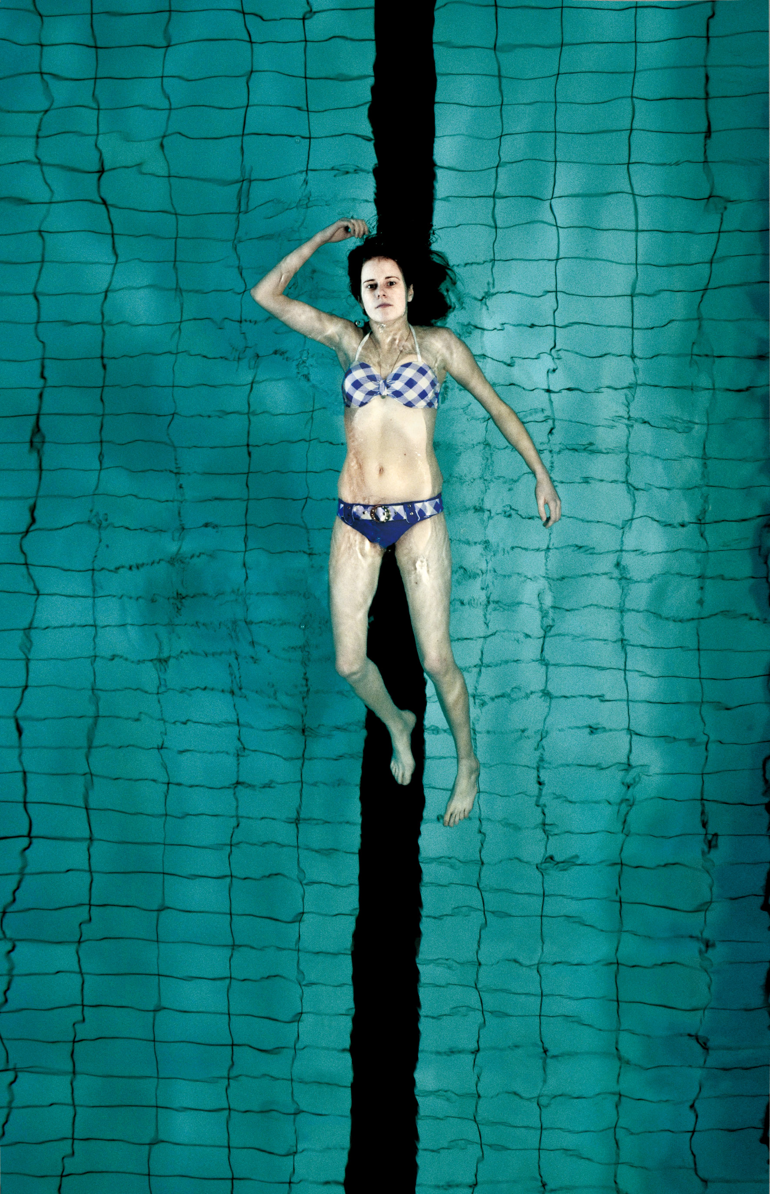

Cast
Ela: Michaela Bendulová
Roby: Robert Roth
Iveta: Venuša Kalejová
Mirka: Lenka Habrunová
Nikola: Kika Potočná
Jolana: Žaneta Polhošová
Zuza: Sandra Radičová
Jana: Dominika Kmeťová
Mother: Katarína Feldeková
Jojo: Peter Slivovský
Old Man: Ľudovít Kállay
Director: Zuzana Struhárová
Main Warden: Ela Lehotská
Wardens: Kamil Bartko, Andrej Ivan

Crew
Written by: Marek Leščák Juraj Lehotský
Directed by: Juraj Lehotský
Cinematography by: Noro Hudec, ASK
Editor: Marek Šulík
Sound: Marián Gregorovič, Peter Mazáček
Set designer: Juraj Fábry
Costume designer: Erika Gadus
Producers ARTILERIA: Ján Meliš, Marko Škop
Producers NEGATIV: Petr Oukropec, Pavel Strnad
Creative producer ČT: Kamila Zlatušková
Line producer: Miša Jeleneková

c) ARTILERIA, Negativ, Česká televize 2013

www.zazrakfilm.com

Technical info
Title: Miracle
Duration: 78 min.
Origination: Digital Camera RED
Ratio: 1:1,85
Format: 35 mm / DCP
Sound: Dolby Digital 5.1.
Language: Slovak
Year of production: 2013

Logline

The story of 15-year-old Ela who is sent to a re-education centre. She yearns for love, but is not allowed to love. Despite all the restrictions, she decides to live her life to the full. However, life is not so much what we want but what we get to live. Sometimes it is suffering and when we hit rock bottom we have to believe in miracles.

Synopsis
The girls are fourteen and fifteen years old and have already experienced more than most adults. Truancy, escapes from home, prostitution, drugs, life on the streets and misguided loves, even though they are still children. They have incomplete families and botched up lives. Re-education centres are full of them.

Ela has a child’s face, but her body is very feminine despite her age. The first evening after her mother drives her to the re-education centre, she has to stand on an impromptu stage where she is subjected to the so-called public confession. We learn that she had a thirty-year-old boyfriend Roby who she met regularly and lived with when she ran away from home. Ela loves him, but she is not allowed to contact him. She decides to run away from the centre during the New Year’s Eve disco.

Director’s statement

I like to reveal new lives, other lives and I think about their purpose and search for their value. The film was inspired by a girl that I met. She was just a child and her whole world had collapsed around her. The young girl has not yet stopped being a child and she loses everything she loved – whatever was a part of her childhood, discos, childhood dreams and her first love. She is starting to live a life she has not been prepared for… I wanted to see her life as it was... to live her life with her own little secret… in absolute simplicity and mediocrity… I wanted to be close to her….
Juraj Lehotský, 2012

Role: ELA
Michaela Bendulová was born in Rožňava in 1993. The makers of the film discovered her in a re-education centre. She was one of the girls in the centre when, after almost two years of searching for the main protagonist of the film, director Juraj Lehotský selected her as the ideal actress for the role of Ela. Her own, direct experience of the difficult environment helped her slip readily and naturally into the role of Ela.

Role: ROBY
Robert Roth was born on 28 October 1972 in Bratislava. In 1987-1993 he studied at the Conservatoire in Bratislava – Music and Drama. Member of the Slovak National Theatre´s Drama Ensemble.

Most significant roles in theatre:
S. Mroźek – Tango – Artur
A. Jarry – Ubu the King – Ubu
E. Rostand – Cyrano de Bergerac – Christian
Moliére – The Misanthrope – Alceste
W. Shakespeare – Twelfth Night – Feste the jester
W. Shakespeare – The Tempest – Ariel
W. Shakespeare – Hamlet – Hamlet
W. Shakespeare – Antony and Cleopatra – Caesar
Hollyroth – Holly, Swatopluk
J. W. Goethe – Faust – Faust
A. P. Čechov – Ivanov – Ivanov

Awards:
Nomination for DOSKY 2000 Award W.Shakespeare The Tempest ARIEL
Award for Best Actor Kopřivnice 1997 Ubu the King UBU
Nomination for DOSKY 2006 Award F. M. Dostoyevsky ŠABRIN
DOSKY 2008 Award HAMLET
Tatrabanka Foundation Award to Artists 2008 HAMLET
Literary Fund Premium - 5X
Nomination for the Crystalline Wing 2008
Literary Fund Annual Award – 2008, 2010
Special Award of the Jury, New Drama 2010 Hollyroth
Student Jury Award, New Drama 2010 Hollyroth
DOSKY 2010 Award HOLLYROTH (Best Play of the Season and Best Actor of the Season)
Hollyroth – Most Significant Theatrical Event of the 2010 Season, in the poll taken by the daily SME
Crystalline Wing 2010 – Theatre and Audiovisual Art Category – Hollyroth

Film roles:
1991 In the Morning Fog (V rannej hmle, dir. Ján Zeman) – young Karas
2007 Hrubeš and Mareš (Hrubeš a Mareš, dir. V.Morávek) – Robert Karpati

JURAJ LEHOTSKÝ, scriptwritwer / director

Juraj Lehotský was born on September 19, 1975 in Bratislava. Between 1990 and 1994 studied at the Higher Art and Crafts School in Bratislava (SUPŠ), specialized in photography. Between 1995 and 2000 studied documentary film directing at the Academy of Music Arts in Bratislava (VŠMU).

Short films:

1995 Silent world of Jozko Balaz (Tichý svet Jožka Baláža) (18min)

1996 With Enough Effort We´ll Have Diplomas (Budeme mať výkony, budeme mať diplomy)
(19min)

1997 A Funeral is Actually a Premiere (Pohreb je vlastne premiéra) (20 min)

1998 Unwanted Children (Nechcené deti) (27 min)

1999 Twins (Dvojičky) (20min)
2000 I Wouldn´t Tell I would Love You so Much (Nevedel som, že ťa budem mať tak rád) (15min)

2001 Interview (Rozhovor) (27min)

1999-2008 Profiles of: Juraj Kukura ( 18min), Martin Hollý (18min), Milan Lasica (18min), Miroslav Marcelli (24min), Jozef Gertli Danglár (20min), Ján Lehotský (30min)

Full-length films:

2008 Blind loves (Slepé lásky)

2013 Miracle (Zázrak)

Awards:

Unwanted Children

Prize UNICEF 1999

I Wouldn´t Tell I would Love You so Much

Premium Prize for the Documentary Film National Film Award IGRIC 2000

Blind loves

- CICAE Art Cinema Award 40. Directors’ Fortnight, Cannes 2008

- National nomination for the Academy Award for Best Foreign Language Film 2008

- Nomination for the Most Valuable Documentary Film of the Year Cinema for Peace Awards,

Berlinale 2009

- Golden Taiga 7th Spirit of Fire Film Festival Khanty-Mansijsk 2009

- Golden Eye for the Best Documentary film 4th Zurich Film Festival 2008

- FIPRESCI Prize 10th Motovun Film Festival 2008

- „Discovery of the Year“ - Special Mention of the Jury 5th Reykjavík IFF 2008

- Grand Prix Cinessonne 10th Festival of European Films in Essonne 2008

- Special Mention for the Documentary Film 6th FICCO Mexico City ICFF Festval2009

- Prize for originality and innovative direction 3rd Emotion Pictures Festival, Athens 2009

- Honorary Jury Special Mention 5th International Documentary Film Festival Play-Doc Tui2009

- The Mayor of the Town of Trenčianske Teplice’s award 16th Artfilm 2008

- Audience Award for the Best Documentary film 20th Trieste Film Festival 2009

- Best documentary film 9th Songes d'une nuit, Paris 2008

- Best Romantic Documentary The Fringe Report Awards 2009

- Sun in a Net National Film Award 2008-2009 ( Best documentary film, Best director, Best

screenplay, Best film editing, Best sound mixing)

- Slovak Film of the Year Kinema Film of the Year 2008

- Prize of the Director of the Festival 15 th Etnofilm Čadca 2008

- Special Prize for the Contribution to Slovak Cinema Association of Slovak Film Clubs

- Prize of the Film Critics - Premium Prize for the Documentary Film National Film Award IGRIC

2009

With the financial support
Audiovisual Fund
Ministry of the Culture of the Slovak Republic
Czech State Fund for the Support of Cinema
MEDIA

Partners:
Radio and Television Slovakia - RTVS
Association of Slovak Film Clubs - ASFK
Aerofilms

